Smart Farmer - IOT Enabled Smart Farming Application

SPRINT – 3

|  |  |
| --- | --- |
| **Team ID** | PNT2022TMID50617 |
| **Team Leader** | MARI MUTHU.K |
| **Team Members** | ESAKKI MUTHU.P  SURESH.G  KANNAN.T  THEN RAJAN |

Creating Mobile App Using MIT App Inventor :

* **QR Code for APK download :**

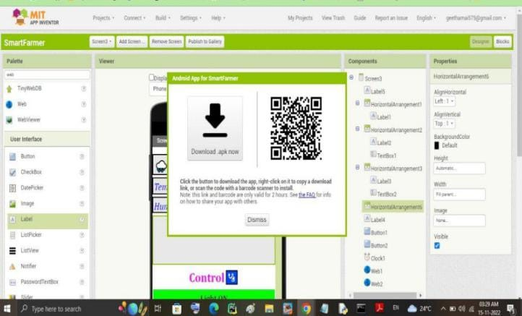

* **Registration Screen :**

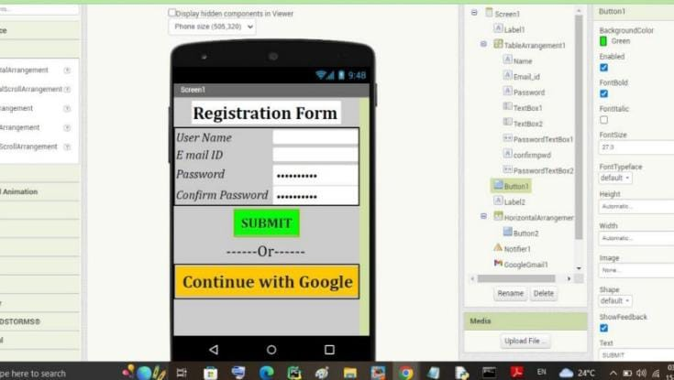

* **Login Screen :**

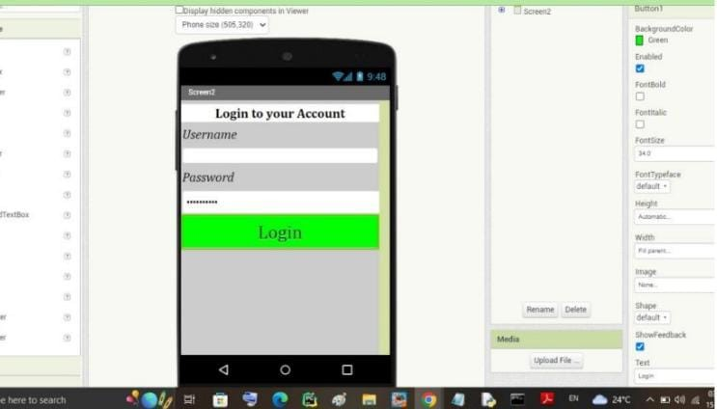

* **Output Screen :**

